Problem Statement & Objectives :
Problem Statement :
Problem Statement
Public transportation systems generate massive amounts of raw data such as trip records, timestamps, and location data. However, this data is often unstructured and difficult to analyze efficiently.
There is a need for a scalable system that can process, clean, and organize this data to enable fast and accurate analytical queries. Without such a system, stakeholders face challenges in identifying patterns like peak hours, demand distribution, and operational inefficiencies.
Objectives
•Build a scalable data pipeline for transport datasets.
•Clean and preprocess raw data for analysis.
•Store data efficiently in a cloud data warehouse.
•Perform analytical queries to extract trends and patterns.
•Automate data processing and query execution.
•Provide dashboards and reports for decision-making.

Functional Requirements
- These describe what the system should do:
- Ingest transport data from CSV files
- Validate data (schema, types, completeness)
- Clean and preprocess data (handle missing and inconsistent values)
- Load processed data into a cloud data warehouse
- Execute SQL queries for trend and pattern analysis
- Support batch processing for data loading
- Automate scheduled query refreshes
- Monitor pipeline execution and query performance
- Generate dashboards and analytical reports

Non-Functional Requirements
- These describe how well the system should perform:
- Scalability: Handle large volumes of data
- Performance: Provide fast query and analysis results
- Reliability: Ensure stable and consistent system operation
- Data Quality: Maintain accuracy and consistency of data
- Maintainability: Easy to update and manage workflows
- Usability: User-friendly dashboards and reports

System Capabilities
These are what the system is able to do:
- Ingest and process transport data from CSV files
- Validate, clean, and preprocess data
- Store processed data in a cloud data warehouse
- Perform SQL-based analysis to detect trends and patterns
- Support batch processing and automated data updates
- Monitor pipeline execution and performance
- Generate dashboards and analytical reports

Constraints
These are the limitations of the system:
- Limited project timeline (implemented in phases)
- Variability in raw data quality
- Dependence on the selected cloud platform and available resources

Use Case Diagram & Descriptions
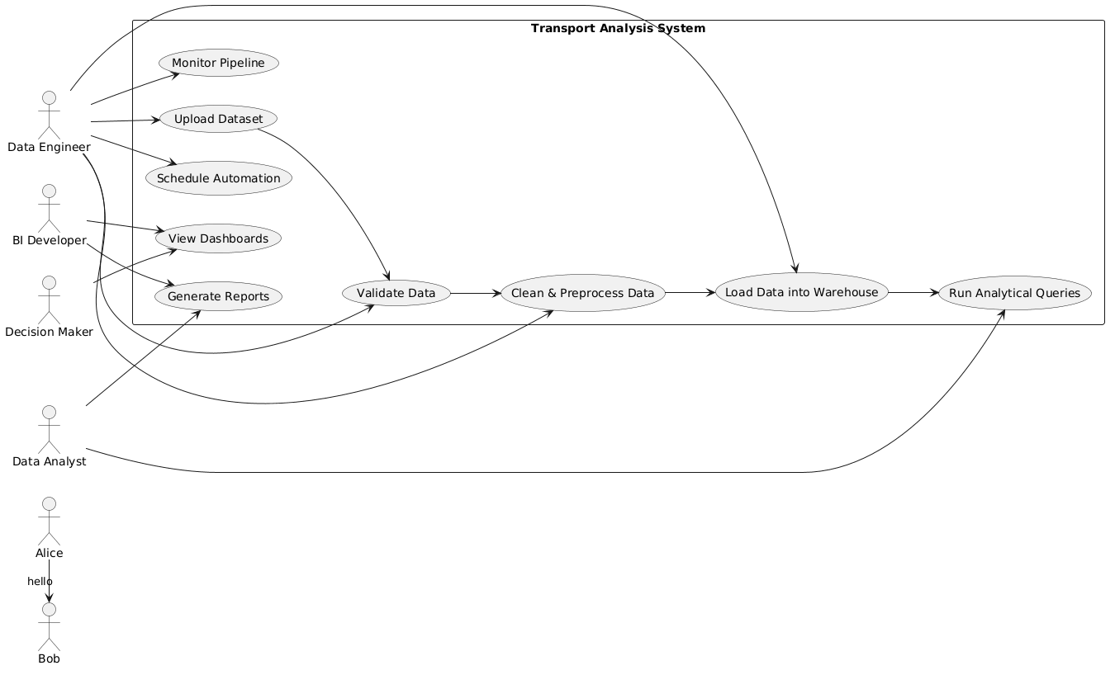

Use Case Diagram Description
The Use Case Diagram illustrates the interaction between the system and its main actors in the transport data analytics system. It shows how each user role (Data Engineer, Data Analyst, BI Developer, and Decision Maker) interacts with the system to perform specific tasks such as data ingestion, processing, analysis, and visualization. The diagram helps visualize the overall workflow from raw data handling to final decision-making insights.

Use Case Descriptions
- Upload Dataset: The Data Engineer uploads transport datasets into the system for processing.
- Validate Data: The Data Engineer verifies the structure, format, and quality of the uploaded data.
- Clean & Preprocess Data: The Data Engineer handles missing values, inconsistencies, and prepares data for analysis.
- Load Data into Warehouse: The Data Engineer loads the cleaned data into the cloud data warehouse.
- Run Analytical Queries: The Data Analyst runs SQL queries to extract insights and identify trends.
- Generate Reports: The Data Analyst and BI Developer create structured reports based on analysis results.
- View Dashboards: The BI Developer and Decision Maker view interactive dashboards to understand insights.
- Schedule Automation: The Data Engineer automates batch processing and periodic query execution.
- Monitor Pipeline: The Data Engineer monitors system performance and ensures successful execution of workflows.

Software Architecture

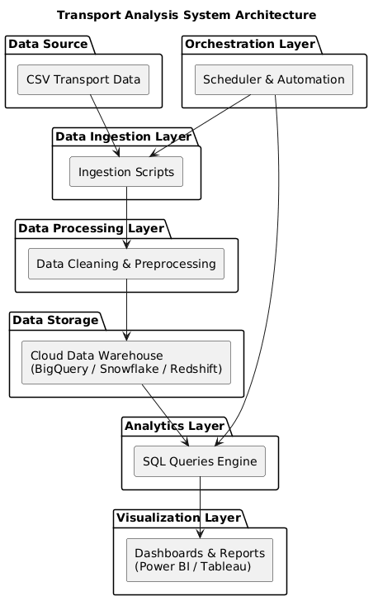

Architecture Overview
The system follows a Data Pipeline Architecture combined with a cloud data warehouse and batch processing approach.
System Components
• Data Source: CSV transport datasets.
• Data Ingestion Layer: Responsible for uploading and ingesting raw data.
• Data Processing Layer: Handles cleaning and preprocessing.
• Data Storage Layer: Cloud data warehouse (e.g., BigQuery, Snowflake, Redshift).
• Analytics Layer: Executes SQL queries for insights.
• Visualization Layer: Dashboards and reports (e.g., Power BI).
• Orchestration Layer: Handles scheduling and automation of batch jobs.

Data Flow
Data flows through the system as follows:
Data Source → Data Ingestion → Data Processing → Data Warehouse → Analytics → Visualization

